**UNIVERSITY OF BERGEN – Hallvard Moan Kristiansen**

**DEPARTMENT OF INFORMATION AND MEDIA STUDIES**   
**2nd Obligatory Assignment Deadline 24.09.2018 at 16:00**   
**INFO125 September 11, 2018**

Samarbeid med hec008.

1.  
2.  
3.

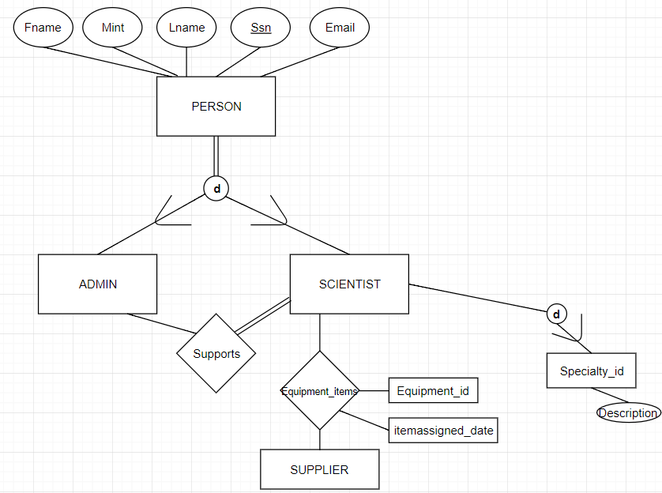

4.

